Name Period

Work and Energy Tinkham Questions

1. A box is being moved with a velocity v by a force P (parallel to v) along a level horizontal floor. The normal force is F_{N}, the kinetic friction ƒ_{k}, and the weight of the box is mg. Decide which forces do positive, zero, or negative work. Provide a reason for each the your answers.

2. A sailboat is moving at a constant velocity.
a. Is work being done by a net external force acting on the boat? Explain.

b. Recognizing that the wind propels the boat forward and the water resists the boat’s motion, what does your answer for part (a) imply about the work done by the wind’s force compared to the work done by the water’s resistive force?

3. A ball has a speed of 15 m/s. Only one external force acts on the ball. After this force acts, the speed of the ball is 7 m/s. Has the force done positive or negative work? Explain.

4. A shopping bag is hanging straight down from your hand as you walk across a horizontal floor at a constant velocity.
a. Does the force that your hand exerts on the bag’s handle do any work? Explain.

b. Does this force do any work while you are riding up an escalator at a constant velocity? Explain.

5. A person is riding on a Ferris wheel. When the wheel makes one complete turn, is the net work done by the gravitational force positive, negative, or zero? Explain.

6. A trapeze artist, starting from rest, swings downward on the bar, lets go at the bottom of the swing, and falls freely to the net. An assistant with the same mass, standing on the same platform as the trapeze artist, jumps from rest straight downward. Friction and air resistance are negligible. On which person, if either, does gravity do the greatest amount of work? Explain.

7. Is it correct to conclude that one engine is doing twice the work of another just because it is generating twice the power? Explain.

8. A neighbor pushes a lawnmower six times further than you, but exerts only half of the force. Which one of you does more work and by how much?

9. A driver slams on his brakes bringing his car to a screeching halt. In the process of coming to a stop, the road does work on the car. Is this work positive or negative? Explain.

10. The drawing shows a boat being pulled by two locomotives through a canal of length 2 km. The tension in each cable is 5,000 N and θ = 20°. What is the net work done on the boat by the two locomotives?
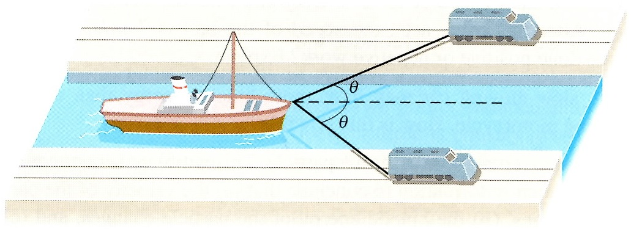

11. A water skier, moving at a speed of 9.3 m/s, is being pulled by a tow rope that makes an angle of 37° with respect to the velocity of the boat. The tow rope is parallel to the water. The skier is moving in the same direction as the boat. If the tension in the tow rope is 135 N, determine the work that it does and power developed in 12 s.

12. How much work is done by a waiter carrying a 50 N tray of food to a table 15 m away?

13. Suppose an open railroad car is rolling without friction in a vertically falling downpour and an appreciable amount of rain falls into the car and accumulates there. Consider the effect of the accumulating rain on the momentum, speed, and kinetic energy of the car.
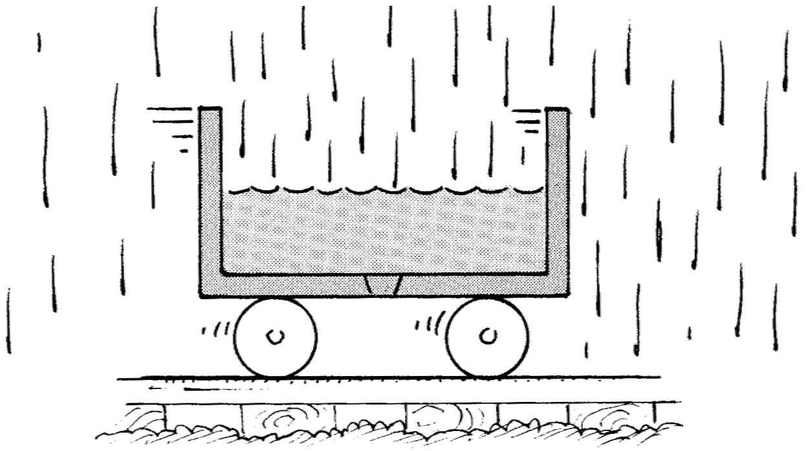
a. Does the momentum of the car increase, decrease, or stay the same? Explain.

b. Does the speed of the car increase, decrease, or stay the same? Explain.

c. Does the kinetic energy of the car increase, decrease, or stay the same? Explain.

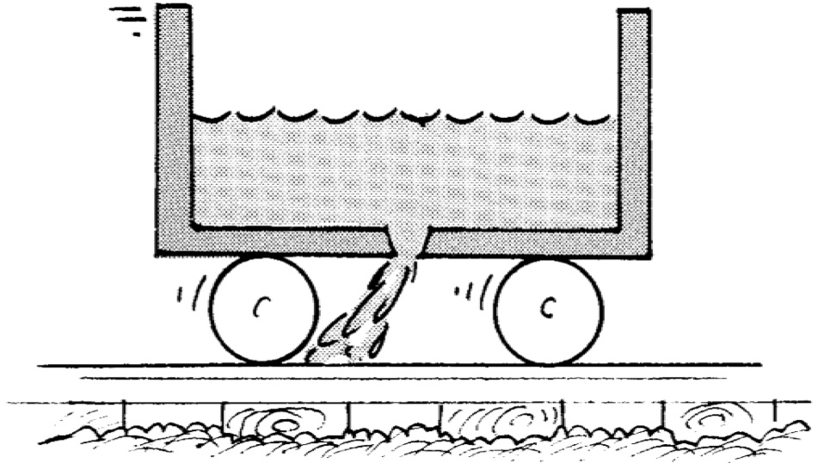
14. The rain has stopped. A drain plug is opened in the bottom of the rolling car allowing the accumulated water to run out. Consider the effects of the draining water on the momentum, speed, and kinetic energy of the car.
a. Does the momentum of the car increase, decrease, or stay the same? Explain.

b. Does the speed of the car increase, decrease, or stay the same? Explain.

c. Does the kinetic energy of the car increase, decrease, or stay the same? Explain.

15. What is kinetic energy? If an object has kinetic energy, what must it be doing?

16. In a simulation on earth, an astronaut in his space suit climbs up a vertical ladder. On the moon, the same astronaut makes the same climb. In which case does the gravitational potential energy of the astronaut change by a greater amount? Explain.

17. A slow-moving car may have more kinetic energy than a fast-moving motorcycle. How is this possible?

18. What is potential energy? On what does potential energy depend?

19. If an object’s speed is tripled, what happens to its kinetic energy? If its kinetic energy doubled, what happens to its velocity

20. A cow moves at a certain speed. A goat has a third of the mass, but moves four times faster. Compare their kinetic energies.
21. A 750 kg automobile is traveling at a typical highway speed of 65 mi/h.
a. How much kinetic energy does the automobile have.

b. By how much would its kinetic energy change if the car traveled half as fast?

c. How fast would the car have to travel to have half as much kinetic energy as in part (a)?

22. About 50,000 years ago, a meteor crashed into the earth near present-day Flagstaff, Arizona. Measurements estimate that this meteor has a mass of about 1.4 x 10⁸ kg and hit the ground traveling at 12 km/s.
a. How much kinetic energy did the meteor have upon impact?

b. How does this energy compare to the energy released by a 1 megaton nuclear bomb, which releases the same energy as a million tons of TNT, and 1 ton of TNT releases 4.184 x 10⁹ J of energy?

23. In the Bohr model of the atom, the ground-state electron in hydrogen has an orbital speed of 2190 km/s. What is its kinetic energy, knowing the mass of an electron is 9.11 x 10⁻²⁷ kg?

24. Is it reasonable that a 30 kg child could run fast enough to have 100 J of kinetic energy? Explain.

25. An archer pulls the bowstring back for a distance of 0.47 m before releasing the arrow. The bow and string act like a spring whose spring constant is 425 N/m. What is the elastic potential energy of the drawn bow?

26. A spring has 160 J of energy when compressed a distance of 0.2 m. What is the potential energy of the spring when it is compressed 5 cm?

27. A spring has a force constant of 1600 N/m. How far must the spring be compressed for 3.2 J of potential energy to be stored in it?

28. A spring with a force constant of 25 N/cm is compressed until it has 11.5 J of potential energy. How far was the spring compressed?

29. The mass of a proton is 1836 times the mass of an electron.
a. A proton is traveling at speed V. At what speed, in terms of V, would an electron have the same kinetic energy as the proton?

b. An electron has kinetic energy K. If a proton has the same speed as the electron, what is its kinetic energy, in terms of K?
30. When an 81 kg adult climbs a staircase to the second floor, his gravitational potential energy increases by 2000 J. By how much does the potential energy of an 18 kg child increase by climbing the staircase?

31. What is the gravitational potential energy of a 55 kg person at the top of the 443 m Sears Tower?

32. By how much does the gravitational potential energy of a 0.6 kg basketball change when it is dropped out of 6.1 m window and caught at a height of 1.5 m?

33. A net external force acts on a particle. This net force is not zero. Is this sufficient information to conclude that
a. the velocity of the particle changes? Explain.

b. the kinetic energy of the particle changes? Explain.

c. the speed of the particle changes? Explain.
34. The speed of a particle doubles and then doubles again because a net external force acts on it. Does the net force do more work during the first or the second doubling? Explain.

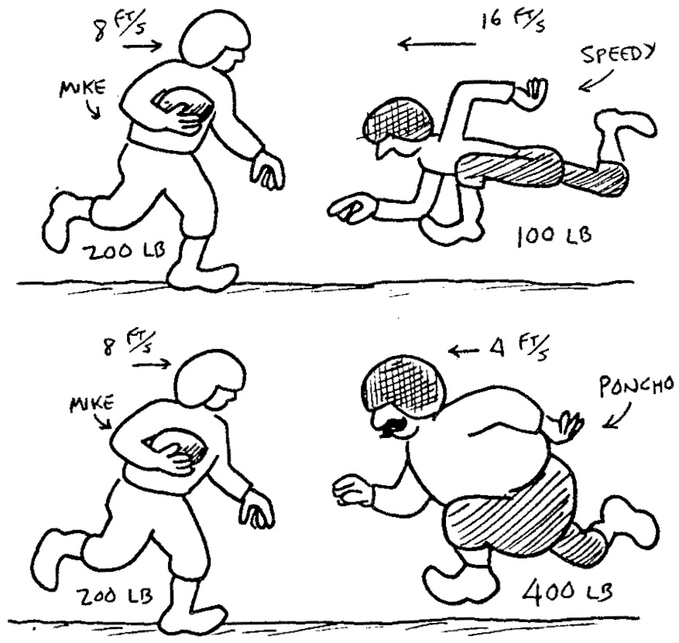
35. Mighty Mike weighs 200 lbs and is running down the football field at 8 ft/s. Speedy Gonzales weighs only 100 lbs, but runs 16 ft/s, while Ponderous Poncho weighs 400 lbs and runs only 4 ft/s. (Do not convert the values.)
a. In the encounter who will be more effective in stopping Mike? Explain.

b. Who is more likely to break Mike’s bones? Explain.

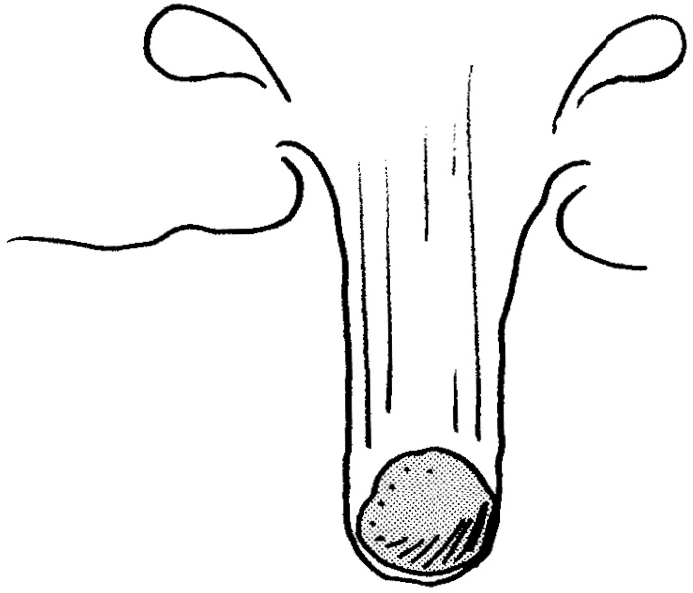
36. You throw a stone into some nice soft and gushy mud. It penetrates one inch. If you wanted the stone to penetrate four inches, how much faster would you have to throw it into the mud?

37. A 65 kg skier slides horizontally along the snow for a distance of 21 m before coming to rest. The kinetic friction between the skier and the snow is 31.85 N. Initially, how fast was the skier going?
38. A person starts from rest and begins to run.
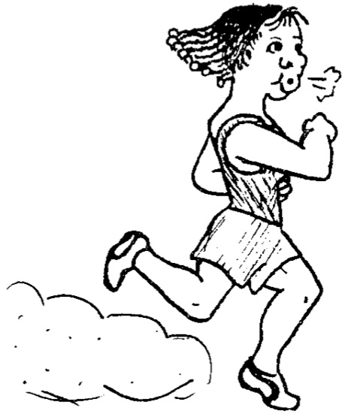
a. The runner puts a certain amount of momentum into herself and more, less, or the same amount of momentum into the ground? Explain.

b. The runner puts a certain amount of kinetic energy into herself and more, less, or the same amount of kinetic energy into the ground? Explain.

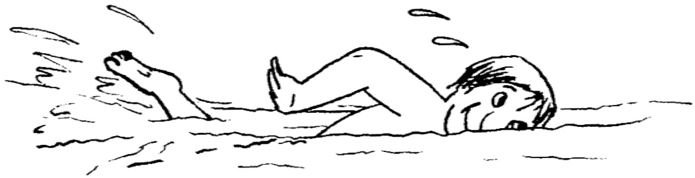
39. A person starts from rest and begins to swim.
a. The swimmer puts a certain amount of momentum into himself and more, less, or the same amount of momentum into the water? Explain.

b. The swimmer puts a certain amount of kinetic energy into himself and more, less, or the same amount of kinetic energy into the water? Explain.

40. One of the tallest and fastest roller coasters in the world is the Steel Dragon in Japan. The coaster has a speed of 3 m/s at the top of the drop and attains a speed of 42.9 m/s when it reaches the bottom. If the roller coaster were to then start up an identical hill, would its speed be 3 m/s at the top of this hill? Assume that friction is negligible. Explain.
41. Suppose the total mechanical energy of an object is conserved.
a. If the kinetic energy decreases, what must be true about the potential energy?

b. If the potential energy decreases, what must be true about the kinetic energy?

c. If the kinetic energy does not change, what must be true about the potential energy?

42. Consider the following two situations in which friction and air resistance are negligible. Car A approaches a hill. The driver turns off the engine at the bottom of the hill, and the car coasts up the hill. Car B, its engine running, is driven up the hill at a constant speed. Which situation is an example of the principle of conservation of mechanical energy? Explain.

43. A trapeze artist, starting from rest, swings downward on the bar, lets go at the bottom of the swing, and falls freely to the net. An assistant, standing on the same platform as the trapeze artist, jumps from rest straight downward. Friction and air resistance are negligible. Who, if either, strikes the net with a greater speed? Explain.

44. A pole-vaulter approaches the takeoff point at a speed of 9 m/s. Assuming that only this speed determines the height to which he can rise, find the maximum height at which the vaulter can clear the bar.

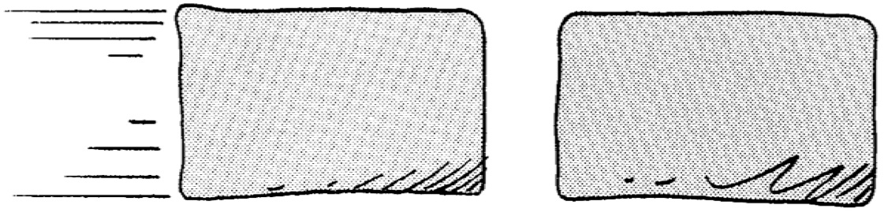
45. A 1 kg lump of clay traveling at 1 m/s smashes into another 1 kg lump of clay, which is not moving. Smush! They stick and become one 2 kg lump.
a. What is the speed of the 2 kg lump?

b. What percentage of the kinetic energy in the originally moving lump was turned into heat during the collision?

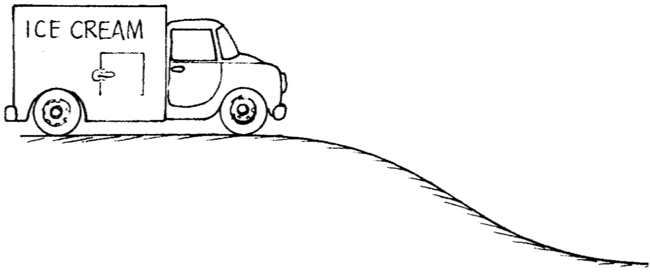
46. A truck initially at rest at the top of a hill is allowed to roll down. At the bottom its speed is 4 m/s. Next, the truck is again rolled down the hill, but this time is does not start from rest. It has an initial speed of 3 m/s on top, even before it starts going down the hill. How fast is it going when it gets to the bottom: 3 m/s, 4 m/s, 5 m/s, 6 m/s, or 7 m/s? Explain.

47. A slingshot will shoot a 10 g pebble 22 m straight up.
a. How much potential energy was stored in the slingshot’s rubber band?

b. With the same potential energy stored in the rubber band, how high can the slingshot shoot a 25 g pebble?

48. A 2 kg block is pushed against a spring with a force constant of 400 N/m, compressing it 0.22 m. When the block is released, what is its speed after having left the spring?

49. A 15 kg stone slides down a snow covered hill from a height of 20 m above the ground below with an initial speed of 10 m/s. What is the speed of the stone as it reaches the bottom of the hill?

50. A baseball is thrown from the roof of a 22 m tall building with an initial velocity of 12 m/s at 53˚ above the horizontal. What is the speed of the ball as it strikes the ground?

51. A block with mass 0.5 kg is forced against a horizontal spring of negligible mass, compressing the spring a distance of 0.2 m. When released, what is the speed of the block as it leaves the spring?
52. A projectile of mass 0.75 kg is shot straight up with an initial speed of 18 m/s.
a. How high would it go if there were no air friction?

b. If the projectile rises to a maximum height of only 11.8 m, how much kinetic energy was converted into heat due to friction?

