Name Period

Waves Tinkham Questions

1. A metronome is a device used by many musicians to get the desired rhythm for a musical piece. If a metronome is clicking back and forth with a frequency of 0.5 Hz, what is the period of the metronome?

2. Many amusement parks feature a ride in which a giant ship swings back and forth. If the period of the ship is 8 s, what is the frequency of the swinging ship?

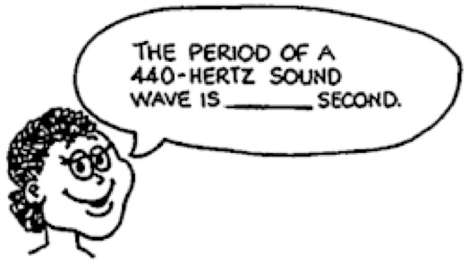
3. What is the period of a 440 Hz sound wave?

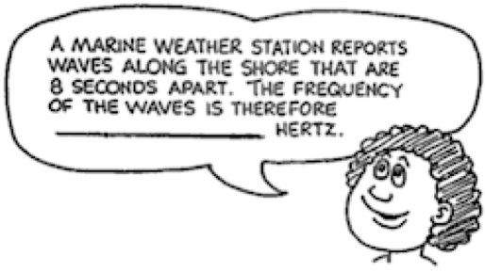
4. A marine weather station reports waves along the shore that are 8 s apart. What is the frequency of the waves?

5. If we double the frequency of a vibrating object, what happens to it period?

6. A weight suspended from a spring bobs up and down over a distance of 20 centimeters twice each second. What is its frequency? Its period? Its amplitude?

7. In terms of wavelength, how far does a wave travel during one period?

8. The reading on a metronome indicates the number of oscillations per minute. A metronome is set at 180 oscillations per minute. What are the frequency and period of the metronome?

9. What is the source of all waves?

10. How do frequency and period relate to each other?

11. What is it that moves from source to receiver in wave motion?

12. How is energy of a wave related to its amplitude?

13. As waves pass by a duck floating on a lake, the duck bobs up and down but remains in essentially one place. Explain why the duck is not carried along by the wave motion.

14. Two musical notes A and B are show, one at a time, on the oscilloscope as seen below.
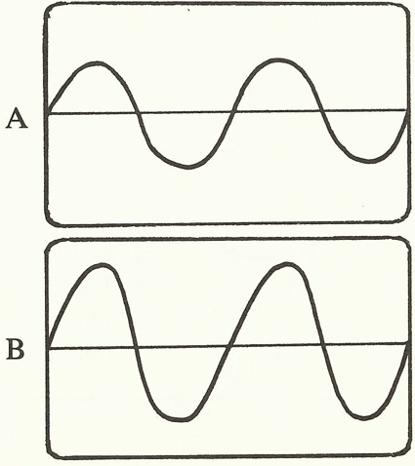
a. Which note has the highest frequency? Explain.

b. Which note is the loudest? Explain.

15. If the frequency of a sound wave is doubled, what change occurs in its speed? In its wavelength?

16. You dip your finger repeatedly into a puddle of water and make waves. What happens to the wavelength if you dip your finger more frequently?

17. A skipper on a boat notices wave crests passing his anchor every 5 s. He estimates the distance between wave crests to be 15 m. What is the speed of the waves?

18. What frequency of sound produces a wavelength of 1 meter if the speed of sound is 340 m/s?

19. One end of a rope is wiggled to produce a wave with a wavelength of 0.25 m. The frequency of the wave is 3 Hz. What is the speed of the wave?

20. A wave on a rope has a wavelength of 2 m and a frequency of 2 Hz. What is the speed of the wave?

21. What is the speed of a wave in a spring if it has a wavelength of 10 cm and a period of 0.2 s?

22. A tuning fork produces a sound with a frequency of 256 Hz and a wavelength in air of 1.35 m.
a. What value does this give for the speed of sound in air?

b. What would be the wavelength of this same sound in water in which sound travels at 1500 m/s?

23. A sound wave has a frequency of 261.6 Hz. What is the wavelength of this sound traveling in air at 343 m/s?

24. Sound with a frequency of 261.6 Hz travels through water at a speed of 1435 m/s. What is the wavelength of these waves?

25. The smallest insects that a bat can detect are the size of one wavelength of the sound the bat makes. What is the frequency of sound waves required for the bat to detect an insect that is 0.57 cm long if the sound has a speed of 340 m/s?

26. Identify the type of wave shown in each drawing. Draw and label an arrow showing the direction of the wave movement and an arrow showing the direction of movement of the medium.
a.
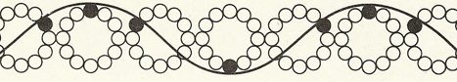

b.
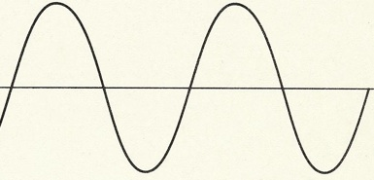

c.
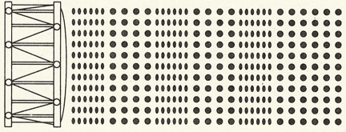

27. What two physics mistakes occur in a science fiction movie that shows a distant explosion in outer space, were you see and hear the explosion at the same time?

28. A cat can hear sound frequencies up to 70,000 Hz. Bats send and receive squeaks up to 120,000 Hz. Which hears shorter wavelengths, cats or bats?

29. At the stands of a racetrack, you notice smoke from the starter’s gun before you hear it fire. Explain.

30. Is it correct to say that in every case, without exception, any radio wave travels faster than any sound wave? Explain.
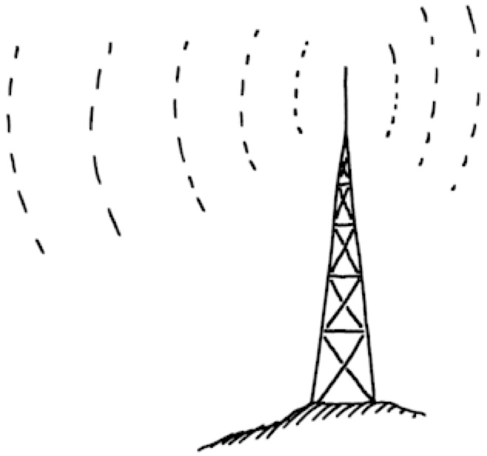

31. Red light has a longer wavelength than blue light. Which has the greater frequency?

32. Microwave ovens emit waves of about 2.45 x 10⁹ Hz. What is the wavelength of this light?

33. When you go out in the sun, it is the ultraviolet light that gives you your tan. The pigment in your skin called melanin is activated by the enzyme tyrosinase, which has been stimulated by ultraviolet light. What is the wavelength of this light if it has a frequency of 7.89 x 10¹⁴ Hz?

34. The Infrared Astronomy Satellite launched by NASA in 1983 had a detector that was supercooled to enable it to measure infrared or heat radiation from different regions of space. What was the frequency of infrared light that has wavelength of 1 x 10⁻⁶ m?

35. The radio station Cat Country broadcasts at a frequency of 98.1 MHz. What is the wavelength of these radio waves?

36. The radio station KSON in San Diego broadcasts at 1240 kHz (AM). What is the wavelength of these radio waves?

37. In old westerns, a cowboy would put his ear down on the ground to check if horses were approaching, or he’d put his ear the to track to check if a train was approaching. Explain.

38. In a transverse wave, in what direction are the vibrations relative to the direction of wave travel?

39. In a longitudinal wave, in what direction are the vibrations relative to the direction of wave travel?

40. Why will sound not travel in a vacuum?

41. How does the speed of sound in water compare with the speed of sound in air?

42. How does the speed of sound in steel compare with the speed in air?

43. What kind of waves exhibit interference?

44. Distinguish between constructive interference and destructive interference.

45. A wave of amplitude 0.3 m interferes with a second wave of amplitude 0.2 m. What is the largest resultant displacement that may occur? Explain.

46. As a dolphin swims toward a fish, the dolphin sends out sound waves to determine the direction the fish is moving. If the frequency of the reflected waves is higher than that of the emitted waves, is the dolphin catching up to the fish or falling behind? Explain.

47. In the Doppler effect, does frequency change? Does wavelength change? Does wave speed change?

48. Can the Doppler effect be observed with longitudinal waves or transverse waves?

49. Would there be a Doppler effect if the source of sound were stationary and the listener in motion? Why or why not? In which direction should the listener move to hear a higher frequency? A lower frequency?

50. When you blow your horn while driving toward a stationary listener, the listener hears an increase in the horn frequency. Would the listener hear an increase in the horn frequency if he were in another car traveling at the same speed in the same direction as you? Explain.

51. Astronomers find that light coming from one edge of the sun has a slightly higher frequency than light from the opposite edge. What do these measurements tell us about the sun’s motion?

52. The Doppler effect can be used to tell if distant stars or galaxies are moving toward or away from Earth. In this case those objects are said to be red or blue shifted depending on which way they are moving. If an object is moving away from Earth, will it be red shifted or blue shifted? Explain.

53. Explain what happens when light is reflected off of a surface.

54. What types of waves can be reflected?

55. What is the law of reflection?

56. In which of the following situations will light from a laser be refracted? Explain.
a. traveling from air into a diamond at an angle of 30˚ to the normal

b. traveling from water into ice along the normal

c. upon striking a metal surface

d. traveling from air into a glass of iced tea at an angle of 25˚ to the normal

57. Sunlight passes into a raindrop (n = 1.33) at an angle of 22.5˚ from the normal at one point on the droplet. What is the angle of refraction?

58. For each of the following cases, will light rays be bent toward or away from the normal?
a. n_{i} > n_{r}, where θ_{i} = 20˚

b. n_{i} < n_{r}, where θ_{i} = 20˚

c. from air to glass with an angle of incidence of 30˚

d. from glass to air with an angle of incidence of 30˚

