Name Period

Heat Tinkham Questions

1. What is temperature?

2. What is meant when saying something is hot?

3. Consider an object at -5˚C. Enough heat is added to make it twice as hot. What is its new temperature?

4. What is the significance of absolute zero?

5. A friend says the temperature inside a certain oven is 500 and the temperature inside a certain star is 50,000. You’re unsure about whether your friend means degrees Celsius or Kelvins. How much difference does it make in each case?

6. The temperature of the sun’s interior is about 10,000,000. Does it matter whether this is degrees Celsius or Kelvins? Explain.

7. On which temperature scale does the average kinetic energy of molecules double when the temperature doubles? Explain.

8. Consider a flask of helium with a temperature of 10˚C. If it is heated until it is twice as hot, what will its temperature be?

9. Why does a penny become warmer when struck by a hammer? Explain.

10. What happens to the molecules of a substance when its temperature increases?

11. Distinguish between thermal energy and temperature.

12. Which has the greater amount of thermal energy, a giant iceberg or a cup of hot coffee? Explain.

13. If two objects are at the same temperature, do they have to have the same amount of thermal energy? Explain.

14. Study the beakers of water shown below. List the beakers in order of thermal energy, least to greatest. Explain why you put them in this order.
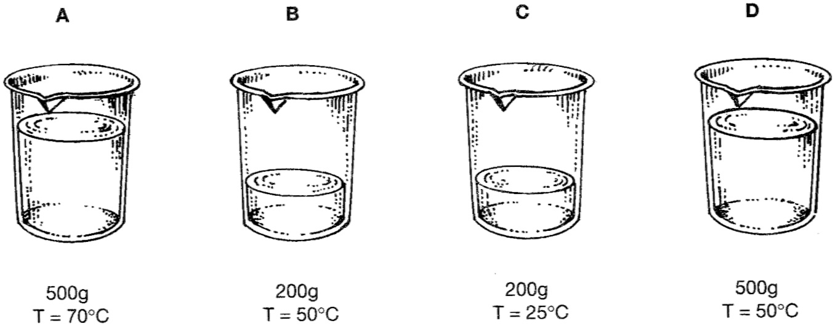

15. Can an object contain heat? Explain.

16. What are the SI units for heat? Explain.

17. What are the common units for heat? What is the conversion to go from metric units to the common units?

18. Distinguish between heat, temperature, and thermal energy.

19. What does it mean for two objects to be in thermal equilibrium?

20. What is meant by the statement, “A thermometer takes its own temperature?”

21. How do two objects become in thermal equilibrium?

22. When you touch a cold piece of ice with your finger, in which direction does heat flow? Explain.

23. What determines the direction of heat flow?

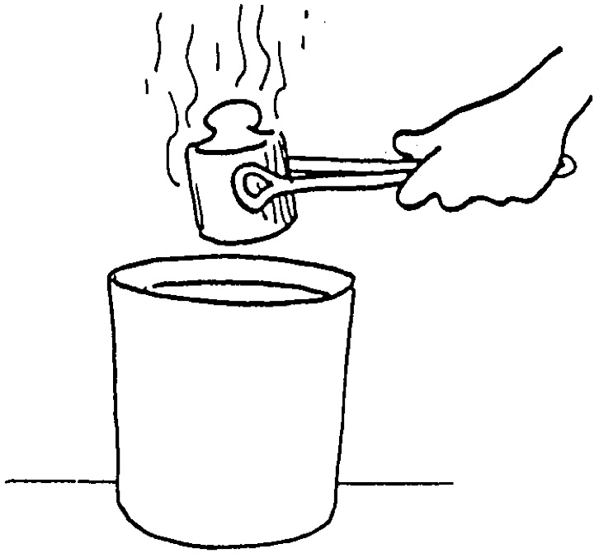
24. A 1 kg red-hot iron mass is put into 1 L of cool water. Explain what happens.

25. When will two objects in contact no longer exchange heat? Explain.

26. Does the ocean get a little warmer when Queen Elizabeth throws the last sip of her hot tea over the rail of the Queen Mary? Explain.

27. What happens to an object’s temperature and thermal energy if it loses heat?

28. What happens to an object’s temperature and thermal energy if it gains heat?

29. Do objects with high temperatures contain a lot of heat? Explain.

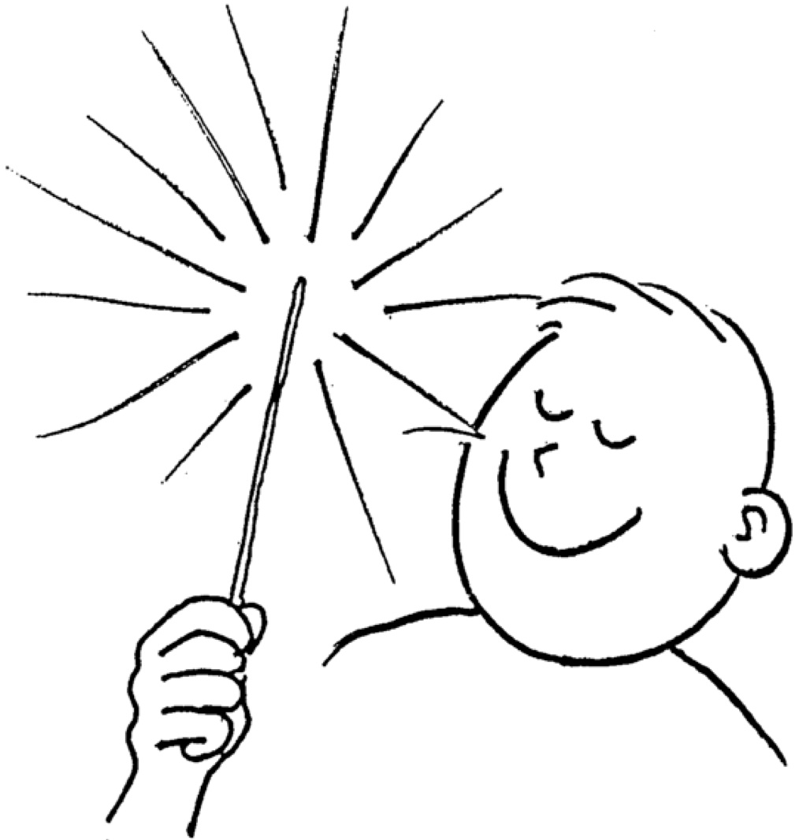
30. Touch the inside of a 200˚C hot oven and you burn yourself, but when the 1200˚C white hot sparks from a 4th of July sparkler hit your skin, you’re okay. Why?

31. Consider an object that is hot relative to its surroundings.
a. Does it have a higher temperature than its surroundings? Explain.

b. Does the object contain more heat than its surroundings? Explain.

c. Will the object contain more thermal energy than its surroundings? Explain.

d. Will there be any heat flow between the object and its surroundings? Explain.

32. Explain the laws of thermodynamics.

33. Why is it absolute zero cannot be reached?

34. Why is absolute zero the lowest possible temperature?

35. From where does the first law of thermodynamics originate?

36. Does the second law of thermodynamics mean heat can never flow from a low temperature to a high temperature? Explain.

37. Adding the same amount of heat to two different objects does not necessarily produce the same increase in temperature. Why not?

38. Why will a watermelon stay cool for a longer time than sandwiches when both are removed from a cooler on a hot day?

39. Why does the presence of large bodies of water tend to moderate the climate of nearby land – make it warmer in cold weather and cooler in hot weather?

40. Desert sand is very hot in the day and very cool at night. What does this indicate about its specific heat capacity?

41. Compared to most substances, does water have a high or low specific heat capacity?

42. What would heat up faster, 100 kg of steel or 100 kg of water? Explain.

43. In a half hour, a 65 kg jogger can generate 800 kJ of heat. This heat is removed from the jogger’s body by a variety of means, including the body’s own temperature-regulating mechanisms (like sweating, etc.).
a. If the heat were not removed, what would be the final temperature of the body, knowing his initial body temperature was 37˚C and the specific heat capacity of the human body is 3470 J/kg·˚C?

b. Explain what would happen to a jogger who could not remove the heat from his body.

44. Cold water at a temperature of 15˚C enters a heater, and the resulting hot water has a temperature of 61˚C. A person uses 120 kg of this hot water in taking a shower. Find the amount of energy needed to heat the water.

45. Nova, whose mass is 50 kg, stays out skiing for too long and her body temperature drops by 2˚C. What is the amount of heat lost from Nova’s body using c_{human} = 3470 J/kg·˚C?

46. Peter is heating water on the stove to boil eggs for a picnic. How much heat is required to raise the temperature of his 10 kg pot of water from 20˚C to boiling?

47. Glass (c_{glass} = 0.84 J/g·˚C) is heated from 19˚C to 72˚C using 15,250 J of heat. How much glass was heated?

48. How much heat is given off when 400 g of ethylene glycol (antifreeze, c = 0.8 cal/g·˚C) cools from 105˚C to 25˚C?

49. What is the specific heat capacity of a substance when 10 g of the substance changed from 70˚C to 85˚C when 69.3 J of heat is added?

50. A 0.05 kg metal bolt (c = 899 J/kg·˚C) is heated to an unknown initial temperature. It is then dropped into 0.15 kg of water with an initial temperature of 21˚C. The bolt and the water then reach a final temperature of 25˚C. What was the initial temperature of the bolt?
51. Answer the following questions based on the figure below. Each container has the quantity of water labeled as the indicated temperatures.
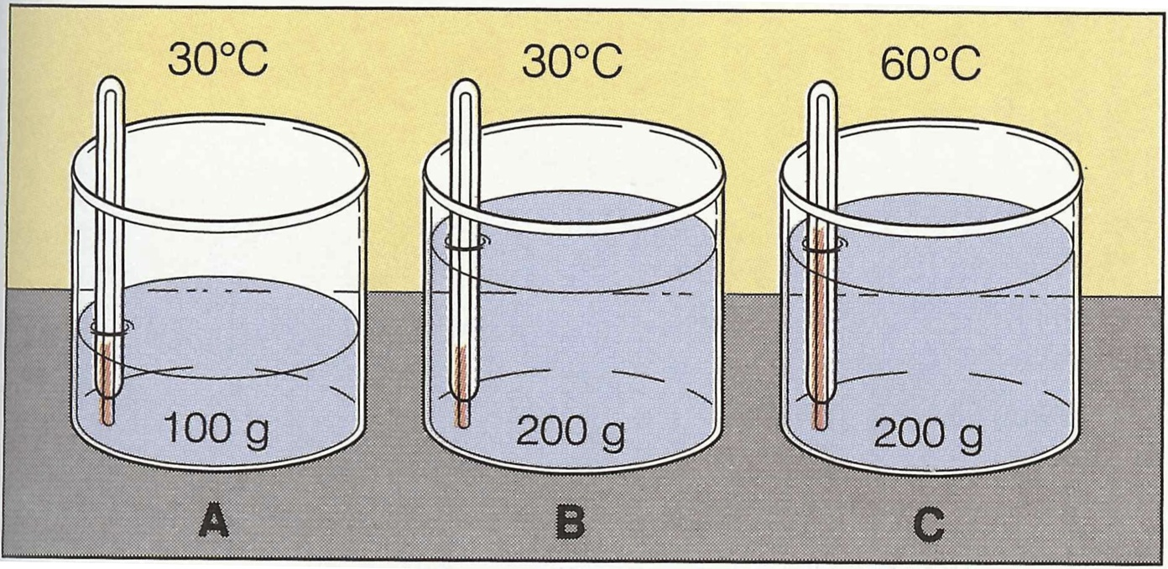
a. In which container is the heat content greatest? Explain.

b. In which container is the thermal energy greatest? Explain.

c. In which container is the motion of the molecules the same? Explain.

d. Compare the motion of molecules in containers A and C. Explain.

e. Compare the average kinetic energy of containers A and B. Explain.

f. Which container needs the greatest amount of heat to raise its temperature by 1˚C? Explain.

52. If water had a lower specific heat capacity, would ponds and lakes be more or less likely to freeze in the winter? Explain.

53. What is the final temperature when a 3 kg gold bar (c_{gold} = 129 J/kg·˚C) at 99˚C is dropped into 0.22 kg of water at 25˚C?

54. Cite an exception to the claim that all substances expand when heated.

55. An old remedy for a pair of drinking glasses that are stuck together (one inside the other) is to run water at different temperatures into the inner glass and over the surface of the outer glass. Which water should be hot, which cold, and why?

56. Explain how a thermometer works using the concepts of thermal expansion and equilibrium.

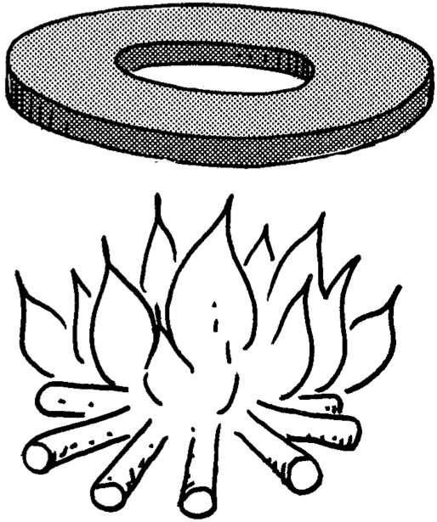
57. A metal disc with a hole in it is heated until the iron expands one percent. What will happen to the diameter of the hole? Will it increase, decrease, or stay the same?

58. A nut is very tight on a screw. Which of the following is most likely to free it, cooling it or heating it? Explain.
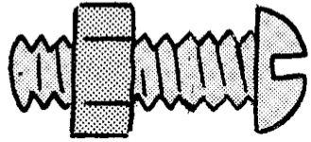

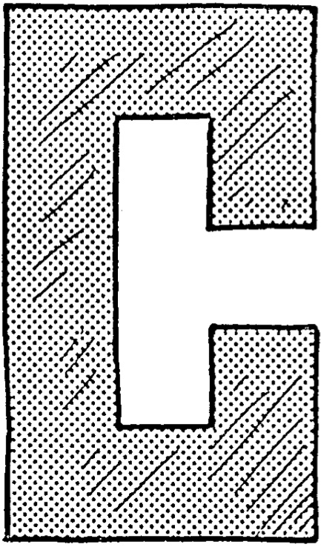
59. When the temperature of the piece of metal to the right is increased and the metal expands, will the gap between the ends become narrower, wider, or stay the same? Explain.

60. Why is it important to protect water pipes so they don’t freeze?

61. Explain why a bimetallic strip bends as it is heated.

62. Long steel bridges often have one end fixed while the other end rests on rockers, as shown. Each sketch shows the bridge at a different season of the year. Which sketch is from the winter and which is from the summer? Explain.

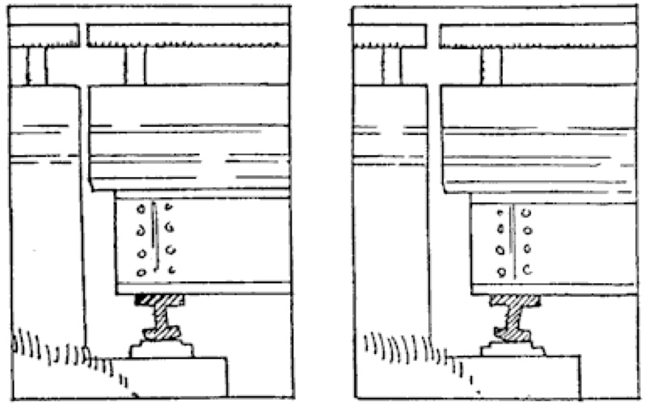

63. When is the best time of day to fill up your gas tank to get the most for your money? Explain.

64. The Eiffel Tower in Paris, made of steel, is 298 m high. On a cold winter night it is shorter than on a hot summer day. By how much does its height change if the temperature changes from 0˚C on a winter night to 30˚C on a summer day? The linear coefficient of thermal expansion for steel is 0.000012 ˚C⁻¹.

65. Mercury (β = 1.82 x 10⁻⁴ ˚C⁻¹) is the only metal that is a liquid at room temperature. If 400 mL of mercury is heated from 20˚C to 350˚C, by how much does its volume change?

66. A typical iron gas tank in a car is able to hold 12 gallons of gas at 20˚C. The gas tank is filled to capacity, but the car is left sitting in the hot sun and reaches a temperature of 45˚C.
a. By how much does the volume of the iron gas tank (β = 3.6 x 10⁻⁶ ˚C⁻¹) expand?

b. By how much does the volume of the gas (β = 9.5 x 10⁻⁴ ˚C⁻¹) expand?

c. How much gas spills out of the gas tank?

d. If gas is $3.50/gallon, how much money is wasted?

